**Business**  **Process** Documentation

**Nusantara Application Certification (NAS)**



|  |
| --- |
| Prepared by: |
| **PT. Nusantara Success Technology**  Jl. Jati Murni No. 30, Jati Padang, Sunday Market  South Jakarta 12540 |



# **Document** version

|  |  |  |  |
| --- | --- | --- | --- |
|  |  |  |  |
| Document Description | 1st Publish |  |  |
| Document Status | Draft verses |  |  |
| Document Change history |  |  |  |
| Date | Created by | Verses | Description of changes |
| 10 Februaryin 2020 | Dap | 1.1 | Initial version of NAS V. 1.1 |
| 25 February 2020 | Dap | 1.1.1 | The change of field TTD assessors and and |
| 26 February 2020 | Dap | 1.1.2 | Added mockup Details for the Assign menuasesmen) |
| 2 Maret 2020 | Dap | 1.1.3 | Portfolio -MUK menu changes |
|  |  |  |  |
|  |  |  |  |

# **Approval** page

|  |  |  |  |
| --- | --- | --- | --- |
| **PT. Nusantara Sukses Teknologi** | | **Pt. Nusantara Sertimedia Application** | |
| Prepared by: | Approved by: | Review by: | Approved by: |
| Rr.Dhianita Apriany T |  |  |  |
| Date: | Date: | Date: | Date: |

Nusantara Application Certification

Business Process Documentation

This document is used to describe the workflow and business process of the Nusantara certification application (NAS). Dokumen This document is an Advanced version of the previousversion, which is version 1.1 (Minimum Viable Product).

# Flow Diagram

This section describes the flow/ business processes that occur in the NAS application .

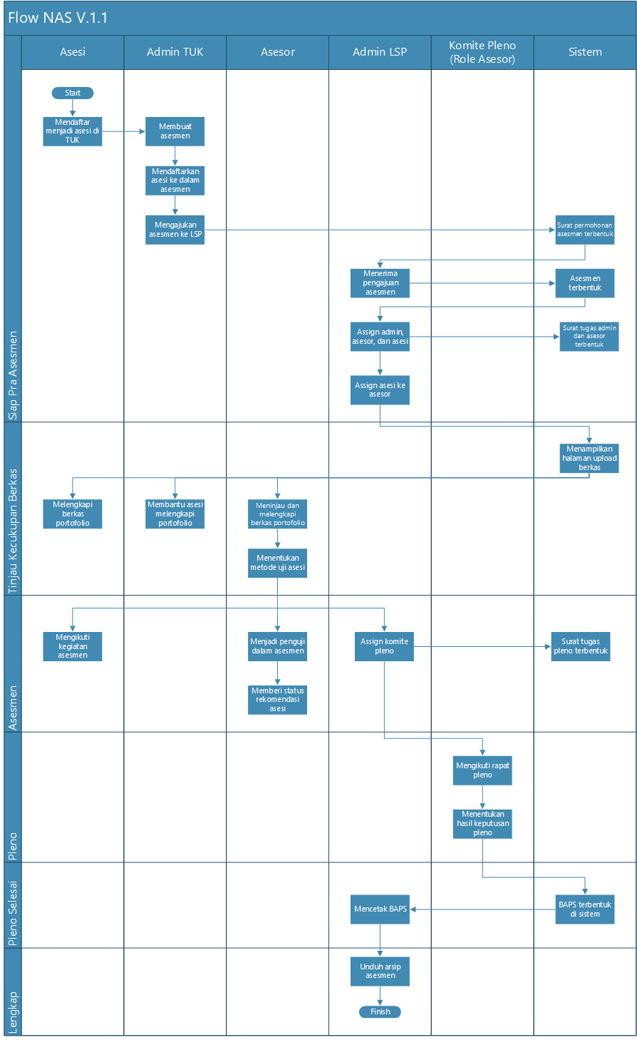

## Description

|  |  |  |
| --- | --- | --- |
| **Nama Use Case** | **Description of Use Case** | **Lead actor** |
| Sign up to be and in TUK | As a first step , and enroll in TUK. | And |
| Creating Assessment | The Admin TUK creates the assessment and selects the desired scheme and schedule . | Admin TUK |
| Registering the and into the Assessment | Admin TUK Register any and who will follow The assessment activities . In this process ini, the TUK admin can also include an and that does not have an account (non account user). | Admin TUK |
| Submitting Assessment to LSP | The telah Admin TUK submits previously created assessment to the LSP. After this, the application letter of assessment will be formed in the system. | Admin TUK |
| Receiving assessment Submission | LSP Admins Accept the application of TUK assessment . | Admin LSP |
| Assign Admins, assessors, and and | LSP Admins Assign admins, assessors, and also and that will follow the assessment. After this, the admin task letter and the Mail task assessment will be formed in the system. | Admin LSP |
| Assign and to the assessor | LSP Admins pair the and to its accessories. | Admin LSP |
| Complete the portfolio file | Asesi is required to complete the portfolio file . The Portfolio is divided into two, General terms and persyaratan basicrequirements. | And |
| Helping and complement portfolios | Admin TUK can help complement the and portfolio file . | Admin TUK |
| Review and complement the portfolio file | Asesor serves to review The completeness of the and file, and can also help to complement its files if needed. | Advisor |
| Determine the and test Method | Asesor determines the test method for and, the yaitu method of testing the portfolio and competence. | Advisor |
| Following assessment Activities | Asesi following the assessment activities that have been scheduled in advance, according to the scheme chosen. | And |
| Become Testers in the assessment | Assessors become testers in the assessmentactivities. | Advisor |
| Assign the Plenary Committee | LSP Admins assign the Plenum Committee , which comprises the chairman of the plenary and anggota Plenarymembers. The Role of the plenary Committee is the Assessor, but should not be the same as the assessors that test in the assessment. After this Plenary task will form in the system. | Admin LSP |
| Give status recommendation of and | Asesor give status recommended or not recommended for and, as a consideration material during Plenarymeetings. | Advisor |
| Join a Plenary meeting | The plenary Committee follows a plenary meeting to determine whether the and is competent or yet competent. | Plenary Committee |
| Determining the results of Plenary decisions | The Plenary Committee issued a Plenary decision for the and. | Plenary Committee |
| Mencetak BAPS | LSP Admins print the news Publishing event certificate. | Admin LSP |
| Download Assessment Archive | The LSP Admin can download the Assessment archive , which contains all data related to the assessment . Including mail, files, etc. | Admin LSP |

Use Case Diagram

In this section will be described the Authority of each user involved. Here 's a user Permissions chart in the aplikasi NAS app:

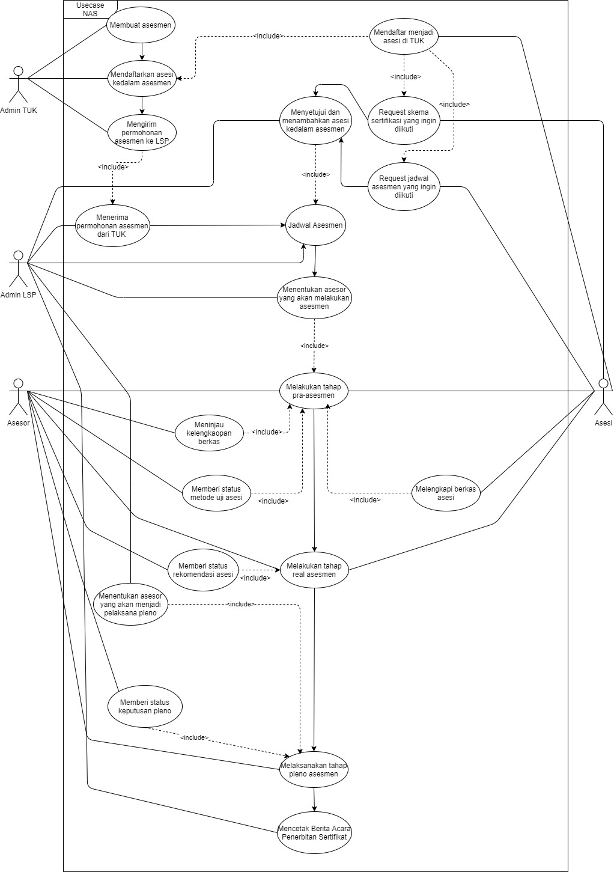

## Admin TUK



In the NAS application , the Admin TUK can perform the followingprocesses:

1. Instruct and to download the application and melakukan Register on the application and.
2. Create the assessment.
3. Registering the and into the assessment, whether already have an account or not.
4. Submit an Assessment schedule to LSP.
5. Assisting the completeness of the and portfolio file (uploading files) if needed.

## Admin LSP



In the NAS app , the LSP Admin can perform the followingprocesses:

1. Receiving the assessment request from TUK.
2. Make the assessment schedule .
3. Set the and into The assessment filed by the previousTUK, or asesmen The assessment made by the LSP admin itu itself.
4. Assign Admins and assessors to the assessment.
5. Assign (pairing) the and to the Assessor assigned to the assessment.
6. To determine the member and Chairman of the plenary into the assessment.
7. Print the news Publishing Certificateevent.

## Advisor



In the NAS application , the asesor can perform the following process :

1. View completeness of and file . This activity is done at the pre -stage assessment and assessment.
2. Providing competency Test status kompetensi to and before carrying out assessment.
3. Conducting assessmentactivities.
4. Provide a status of "recommended" or "not recommended" to the and after the assessment activities took place, as a consideration when Plenary.
5. Conducting Plenary activity. With the notes, the assessors here are the assessors set to be Plenary members (not the same as the assessors that test when the assessment).
6. Give the status of "competent" or "not competent" to and during Plenary.

## And



In the NAS application , asesi can perform the followingprocesses:

1. Download the application NAS and and Create an account, register yourself according to dengan TUK where he registered.
2. To perform the assessment, the and can select the sudah existing assessment Schedule , or choose the available schemes for later review by the LSP admin to make the accessories.
3. Uploading and completing the General requirements and persyaratan Basic requirements of the and NAS application .
4. Conducting assessment activities and waiting for the decision of the Plenary session .

## List of Menu/ features

|  |  |  |  |
| --- | --- | --- | --- |
| **No** | **Menu name/**  **feature** | **Description** | **PIC** |
| 1. | Home | Raises a dashboard containing information related to assessmentactivities. | Admin LSP |
| 2. | Users | Menu to add and manage users (*user*). | Admin LSP |
| 3. | TUK | Menu to register AND manage data TUK. | Admin LSP |
| 4. | Advisor | Menu to Register and manage data assessors, and display a List of skills from the assessors . | Admin LSP |
| 5. | Participants | Display the participant data obtained from the and mobile application , in the assessmentprocess. | Admin LSP |
| 6. | Certification Scheme | Displays a list of skema certification schemes that can be followed by and on kegiatan assessmentactivities. | Admin LSP |
| 7. | Assessment | Is the main menu of the NAS app . In Thismenu, user admin lsp can set the and, assessors, and Plenary members into the assessment. The LSP Admin can also change the state of the assessment, view relateddocuments, and view all the assessment lists , whether still submitted, rejectedor in progress . | LSP Admin/ Asesor |
| 8. | Portofolio | Portfolios are a set of requirements that must be supplemented by and. Portofolio This portfolio consists of General requirements, persyaratan basicrequirements, and competency test (MUK) material . | Admin LSP |
| 9. | Database Asesi | Is a collection of data from the and that has already participated in the assessment activities of the lsp . | Admin LSP |
| 10. | Mail Management | This Menu can only be accessed by the developer, containing the letter templates surat-surat that will be brought to the system at each change of State Assessment. | Developer |
| 11. | Log Data | Through this feature, user can restore (restore) data that has been deleted before. In version 1.1, the data can be restore only the assessment data. | Super Admin |

## WEB Design

Here is an example of Design a NAS plication view for Web lsps :

1. **Login** Page

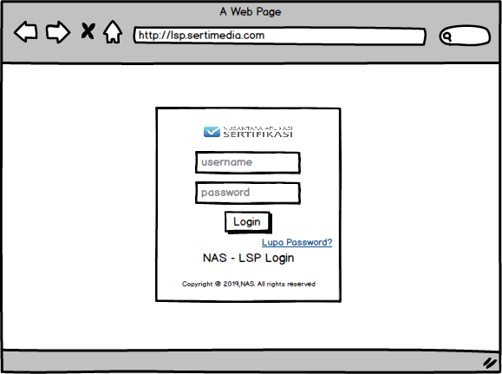

1. **Home** Page

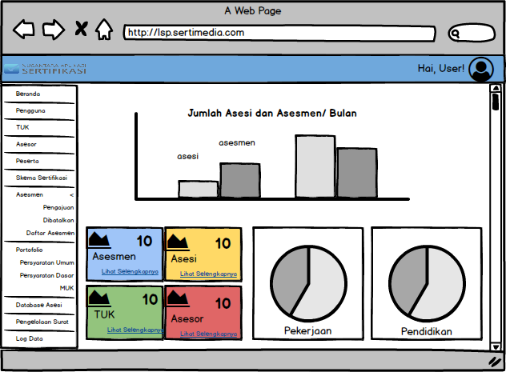

1. **User** Page
2. **User home**  **Pengguna**

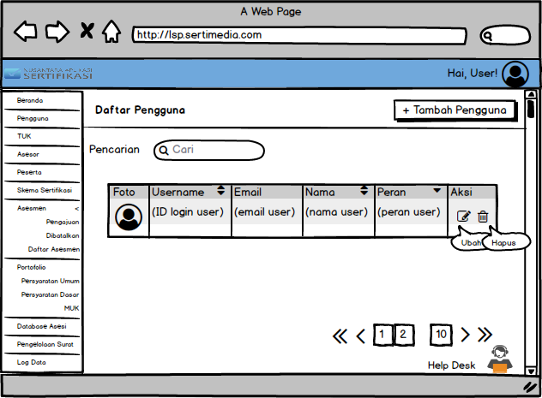

1. **The add**  **users** page

**User Form page (step 1)**

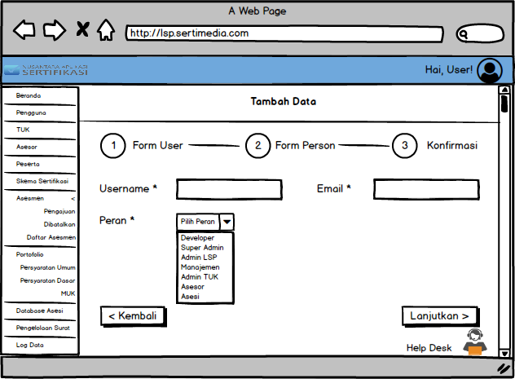

**Person Form page (step 2)**

**Form Person Asesor**

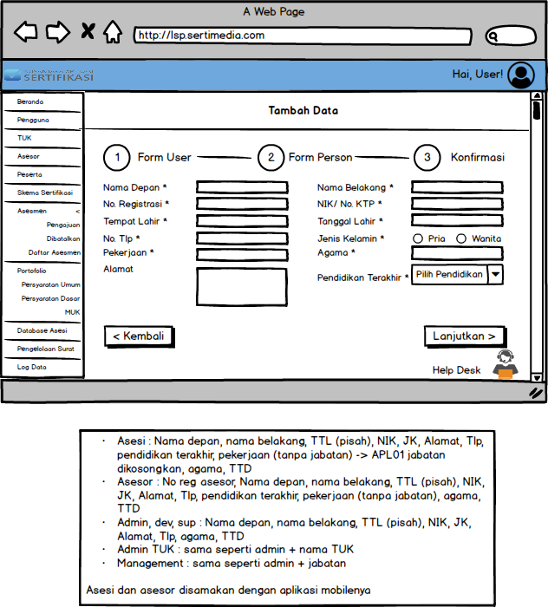

**Form Person Asesi**

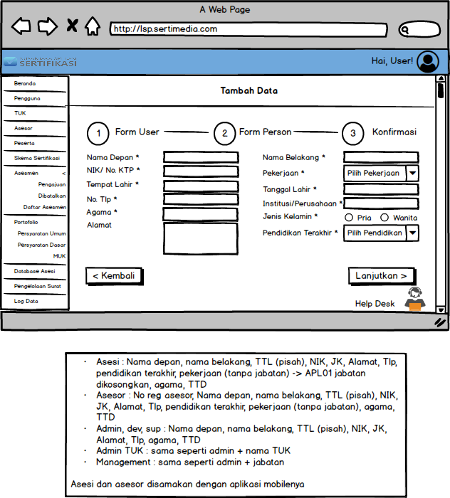

**Form Person Admin, Developer, dan Superuser**

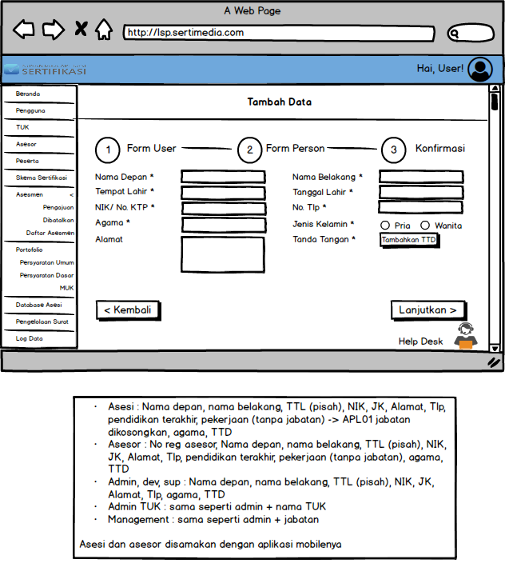

**Form Person Admin TUK**

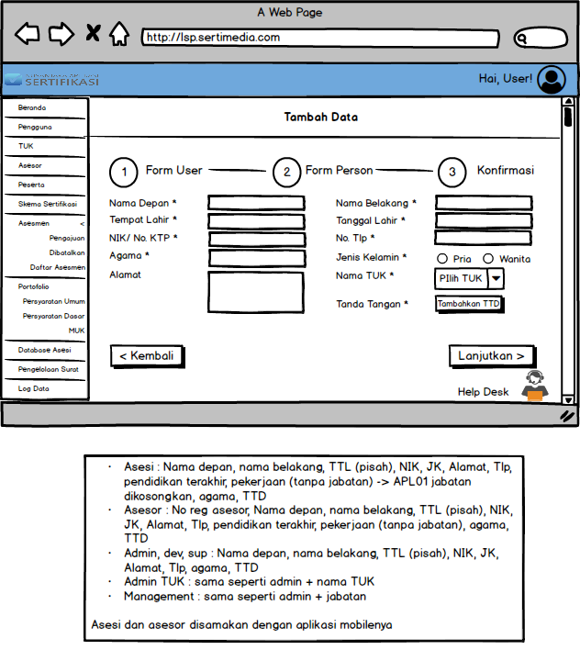

**Form Person Management**

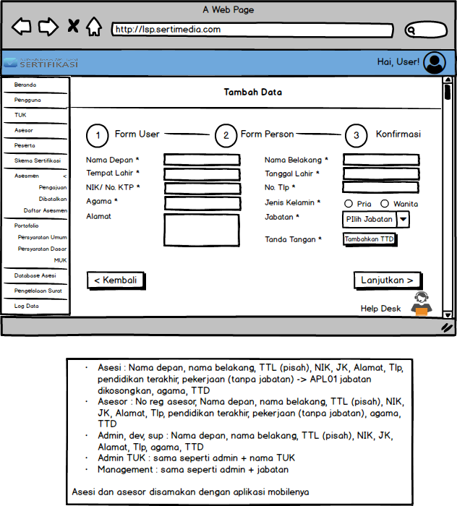

**Confirmation page (step 3)**

**Assessors Confirmation**

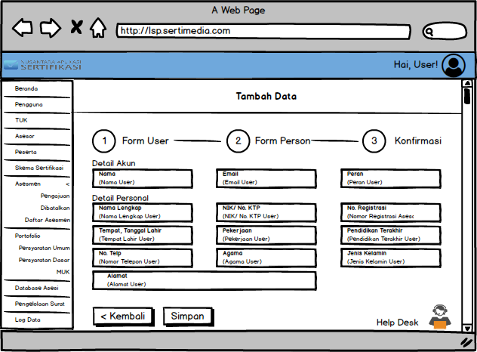

**Confirm Asesi**

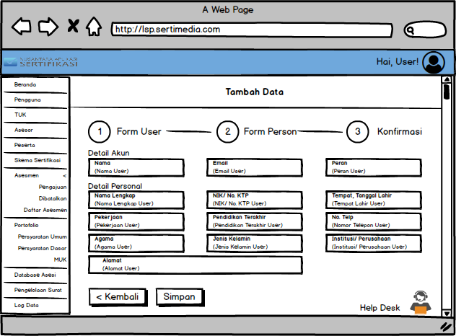

**Konfirmasi Admin, Developer, dan Superuser**

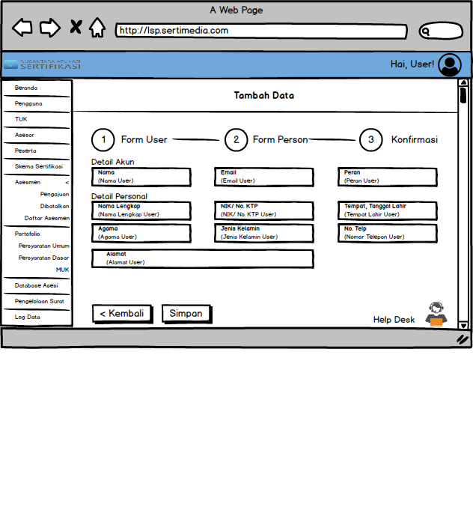

**TUK Admin Confirmation**

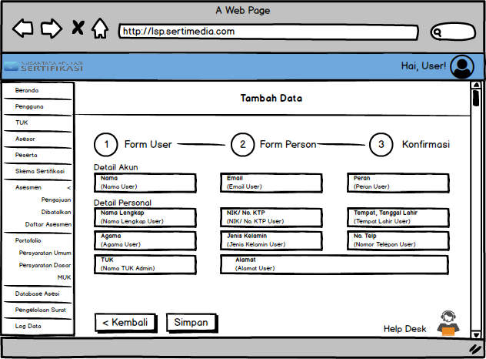

**Management Confirmation**

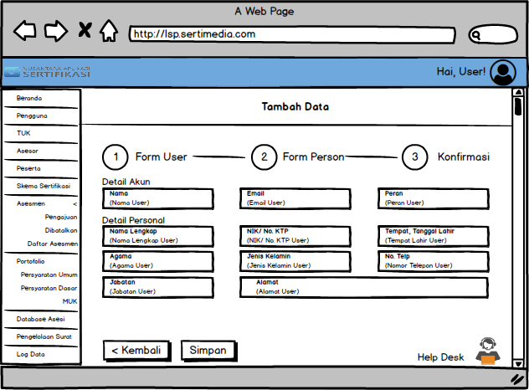

1. **User Edit**  **Pengguna** page

(All fields on the edit page, will be filled in the existing data first)

**Edit User Assessors**

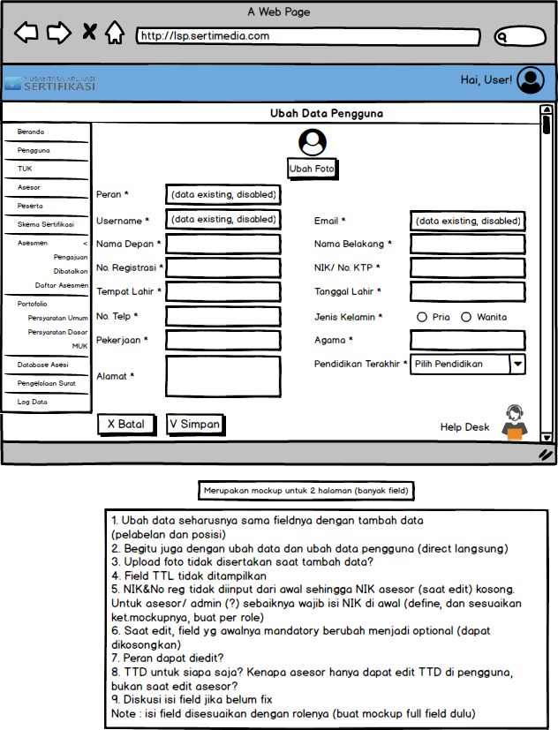

**Edit User Asesi**

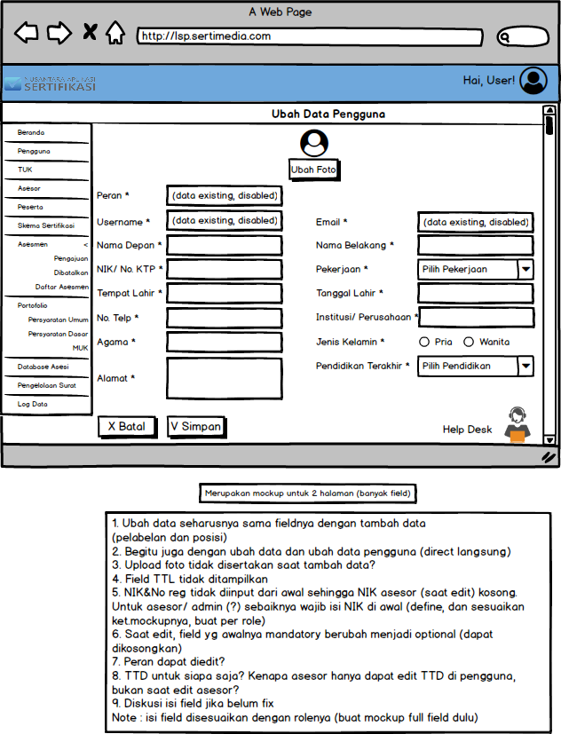

**Edit User Admin, Developer, dan Superuser**

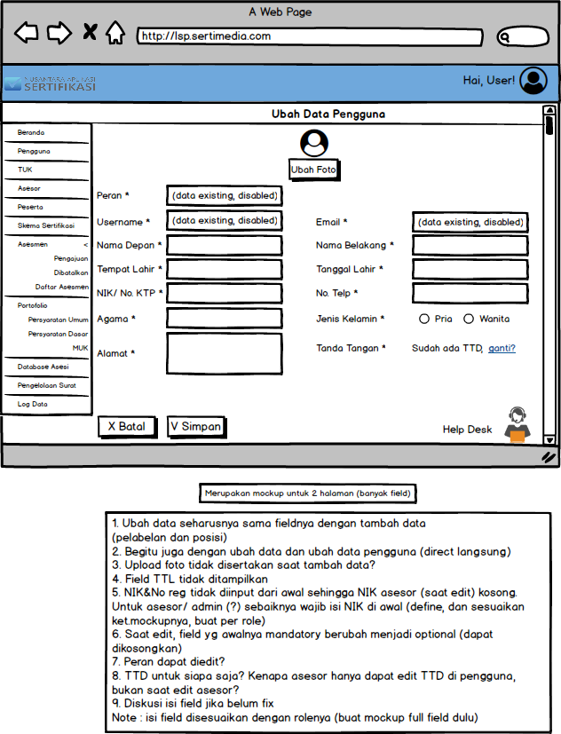

**Edit User Admin TUK**

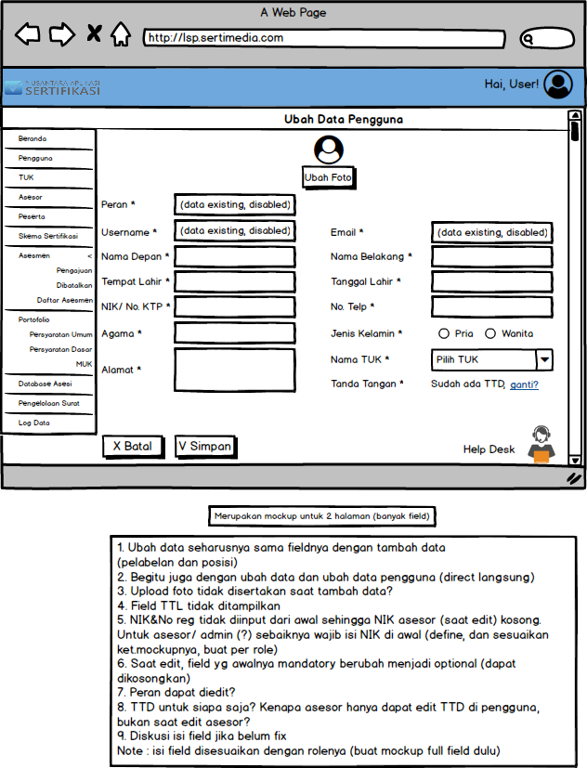

**Edit User Management**

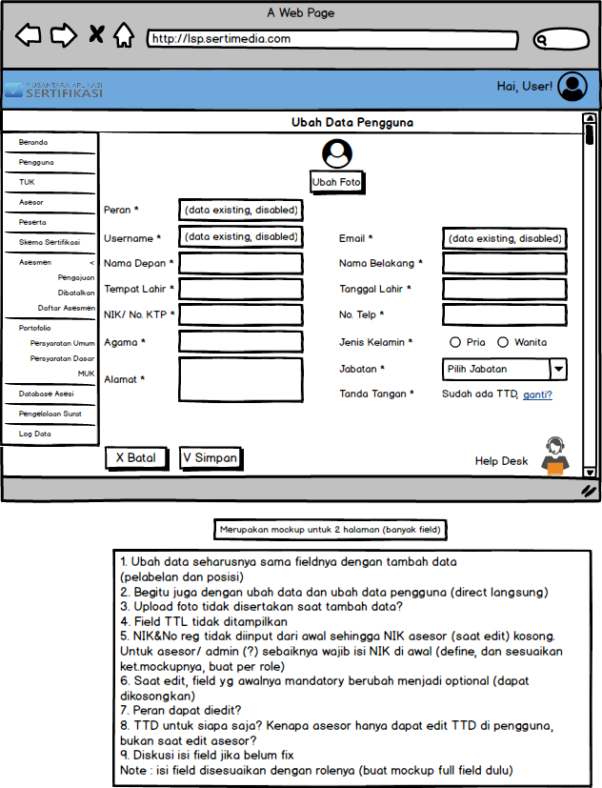

1. **Page TUK**
2. **MAIN TUK** page

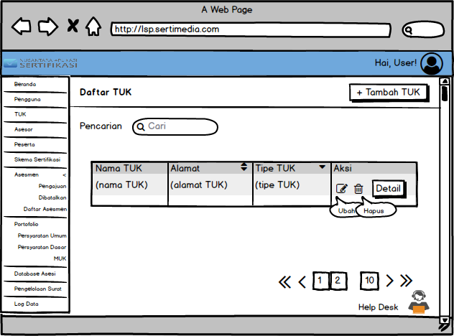

1. **The add**  **TUK** page

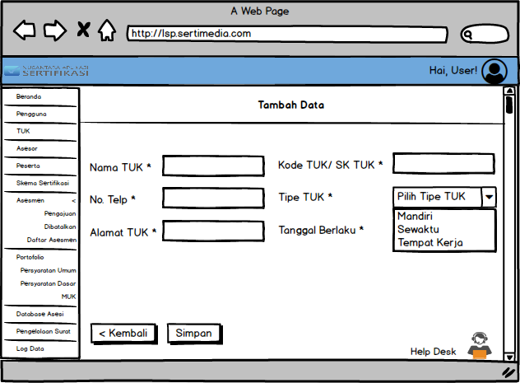

1. **TUK Edit** page

(All fields on the edit page, will be filled in the existing data first)

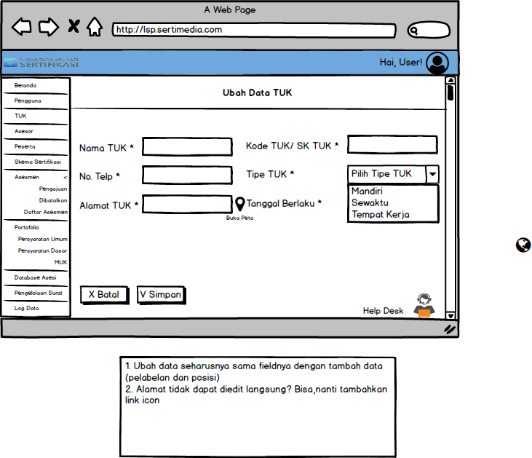

1. **Pop-up Detail TUK**

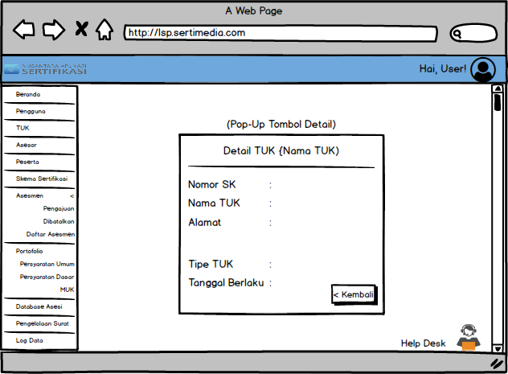

1. **Accessor** Page
2. **Assessor**  **Home** page

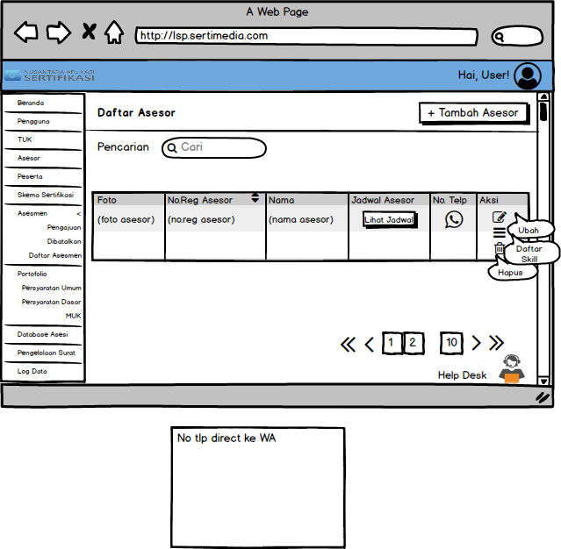

1. **The**  **Assessors** Edit page

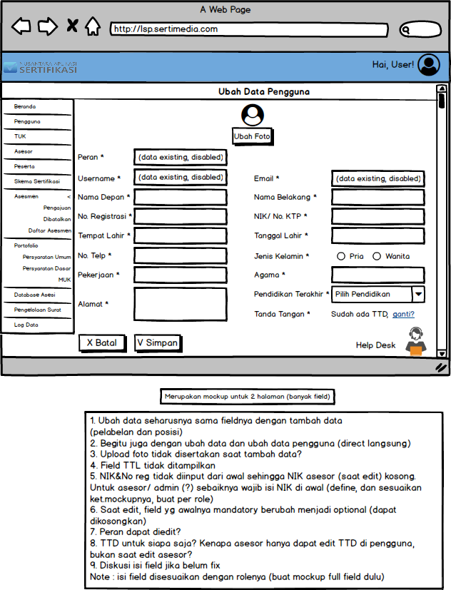

1. **Assessors**  **Skill** page

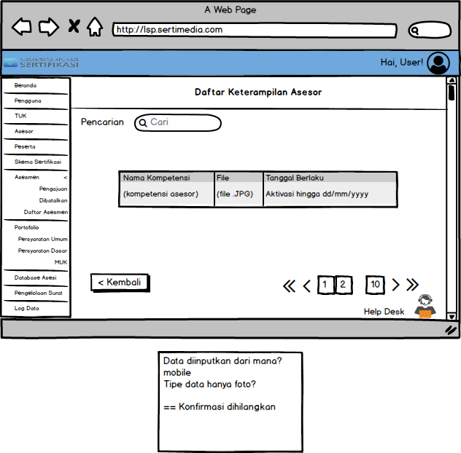

1. **Participant** Page

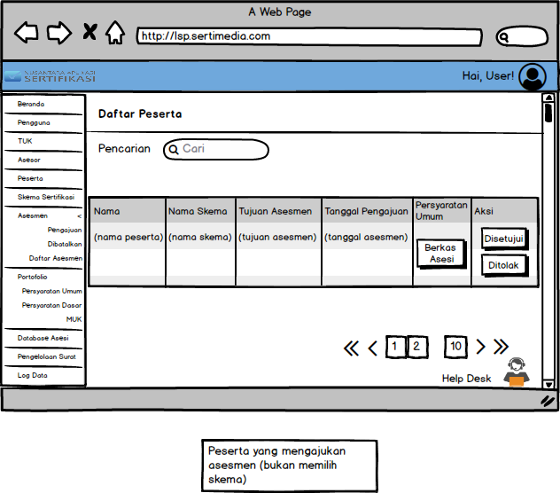

1. **Certification Scheme**  page
2. **Main Page Schema**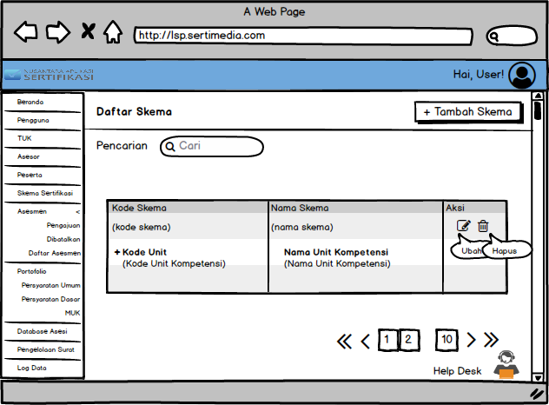
3. **The add**  **schema** page

Step 1

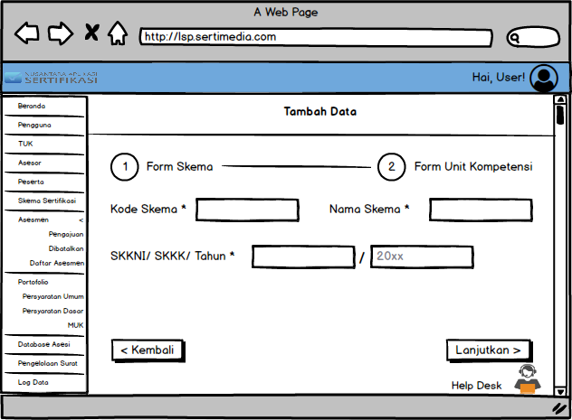

Step 2

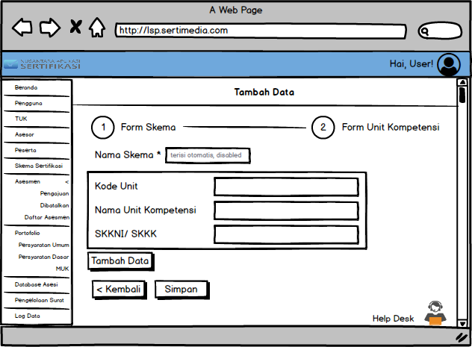

1. **Schema Edit**  **Skema** page

(All fields on the edit page, will be filled in the existing data first)

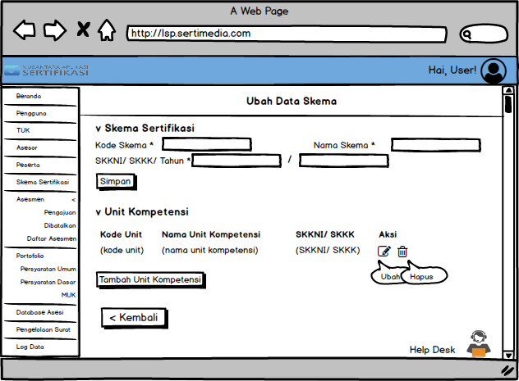

Competency Unit Data can be directly edited without a new page.

1. **Assessment** Page
2. **Assessment Submission**  page

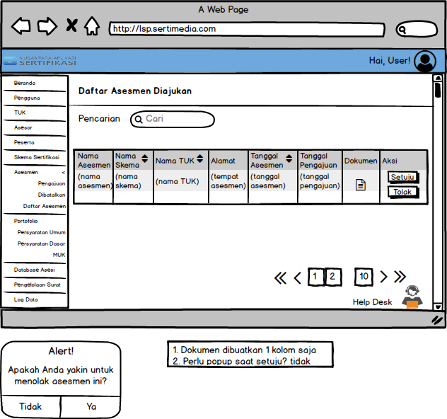

Pop-Up Alert



1. **Assessment Page rejected**

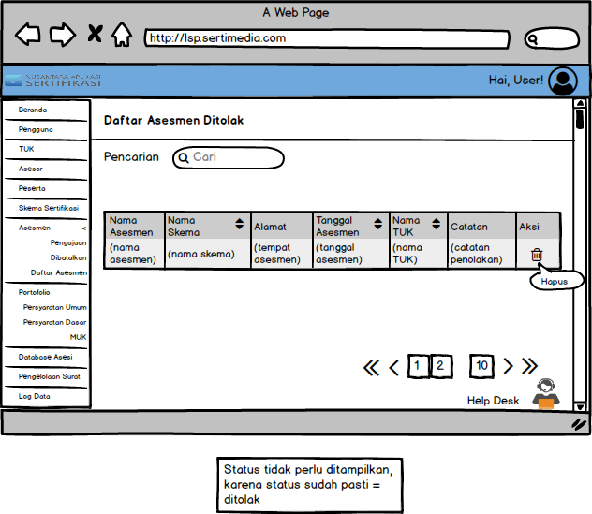

1. **Assessment List**  **Asesmen** page

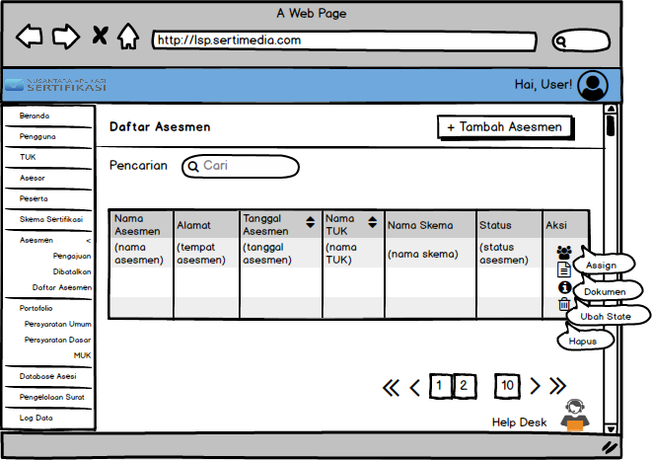

1. **The add**  **Assessment** page

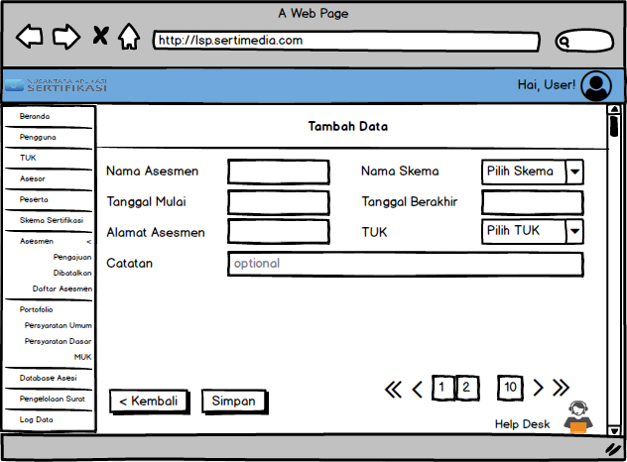

1. **The Assign**  **Assessor** Page

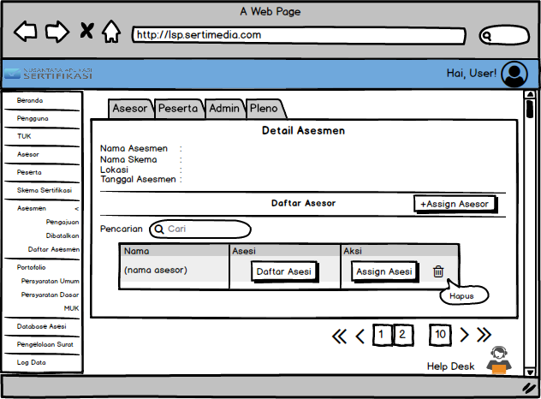

**Assign Assessor** Pop-up

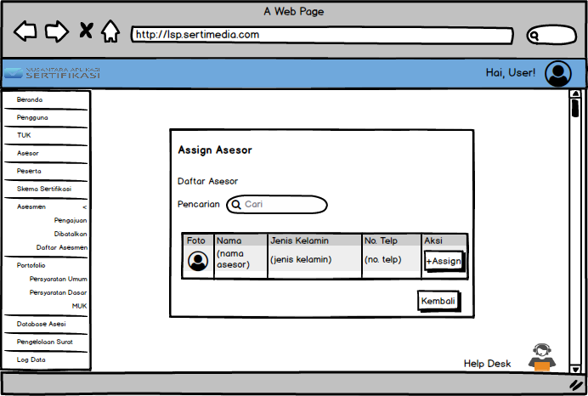

**List of Asesi**

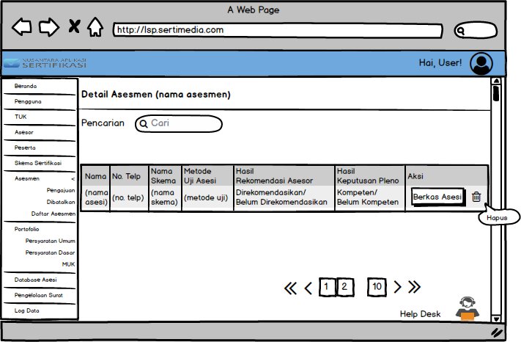

**Asesi** File

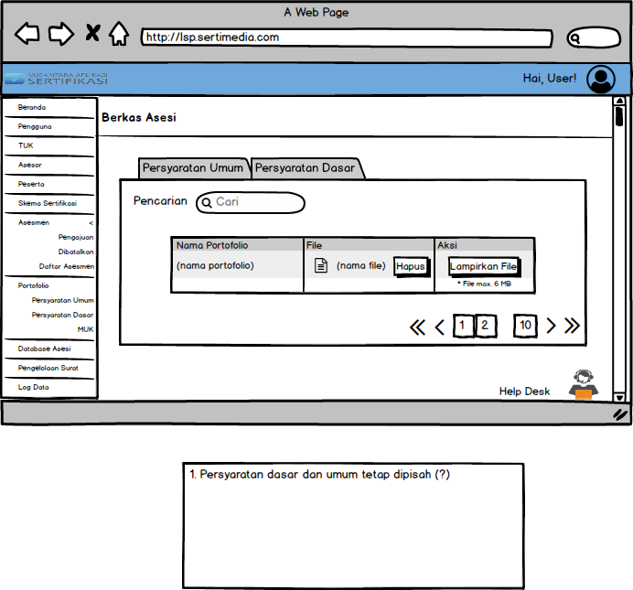

1. **The Assign**  **Attendees** page

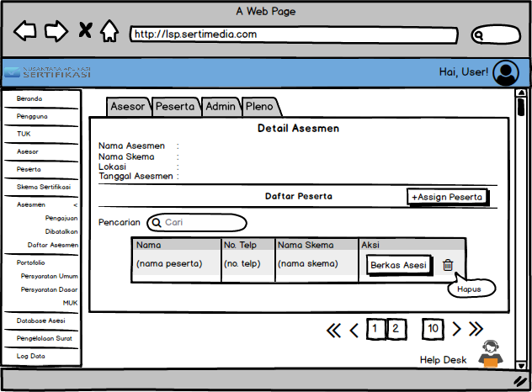

**Assign participant** Pop-ups

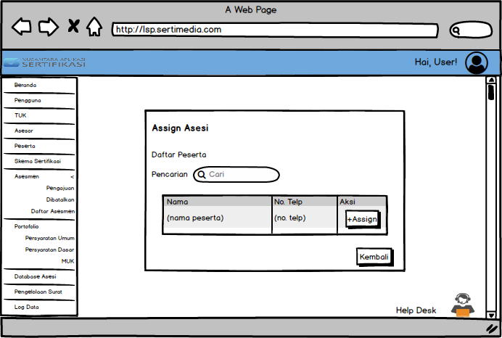

1. **The Assign Admin** page

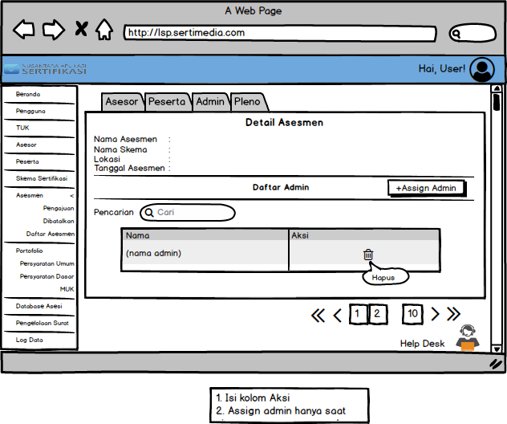

**Pop-up Assign Admin**

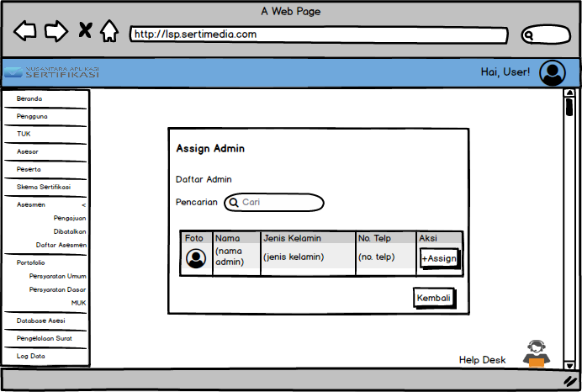

1. **Assign**  **member of**  **Plenary** page

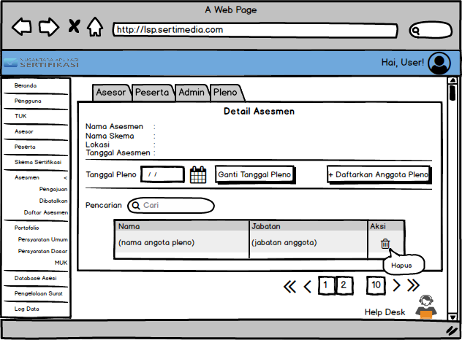

**Assign a pleno** **member**

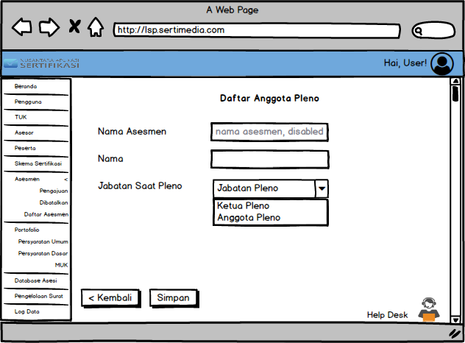

1. **The letter**  **Assessment** page

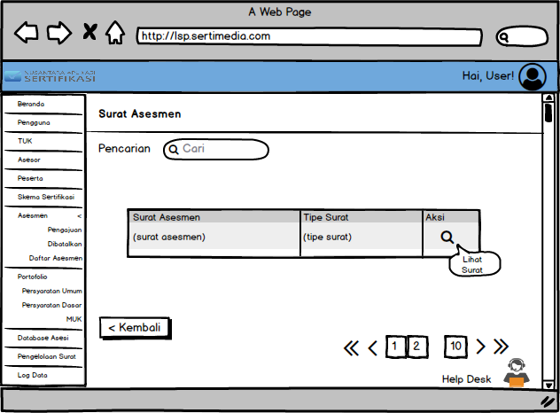

1. **Change**  **State** Pop-up

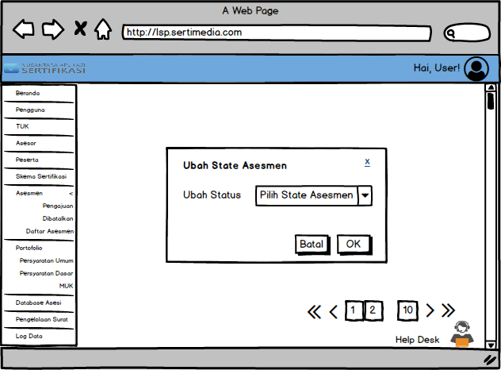

1. **Portfolio** Page
2. **General Requirements**  page

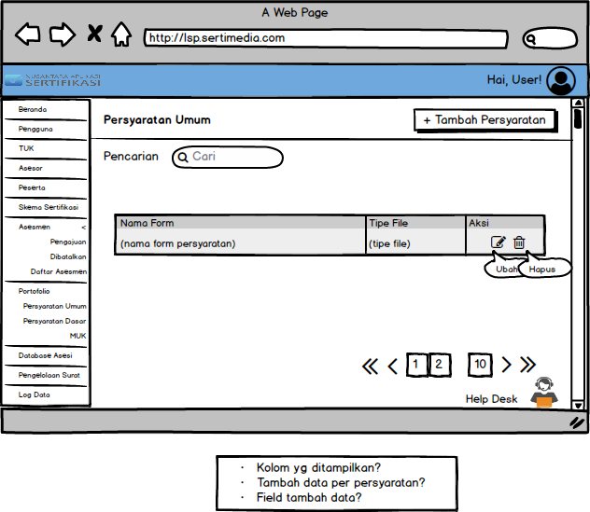

**Add**   **general** requirements

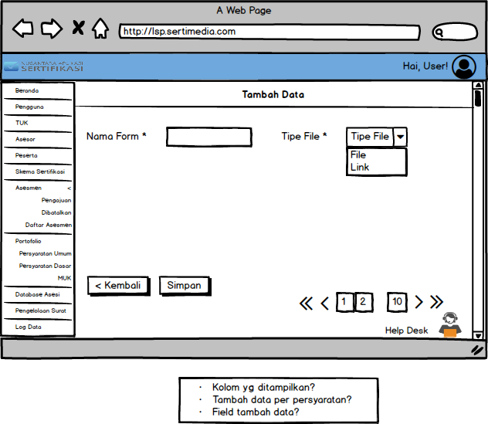

**Edit Persyaratan**  **General** terms

(All fields on the edit page, will be filled in the existing data first)

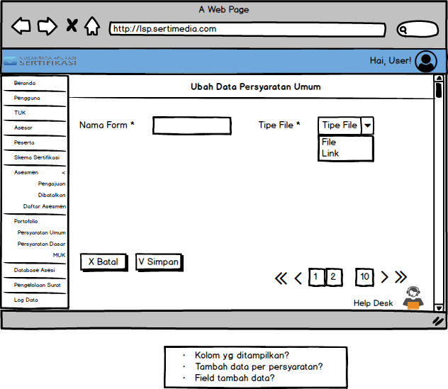

1. **Basic Requirements**  page

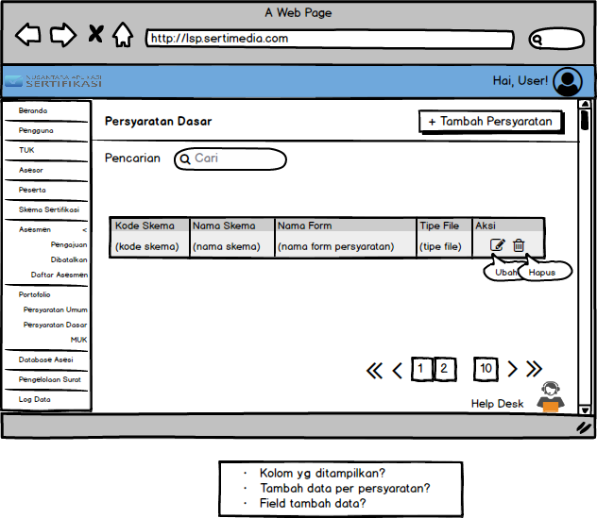

**Add**   **basic** requirements

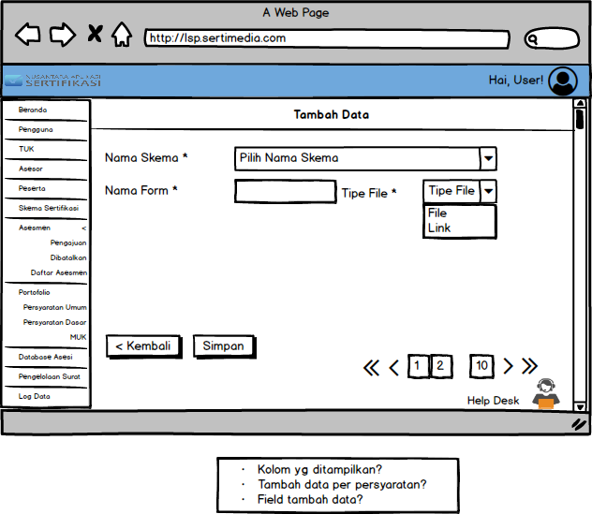

**Edit Persyaratan**  **basic** requirements

(All fields on the edit page, will be filled in the existing data first)

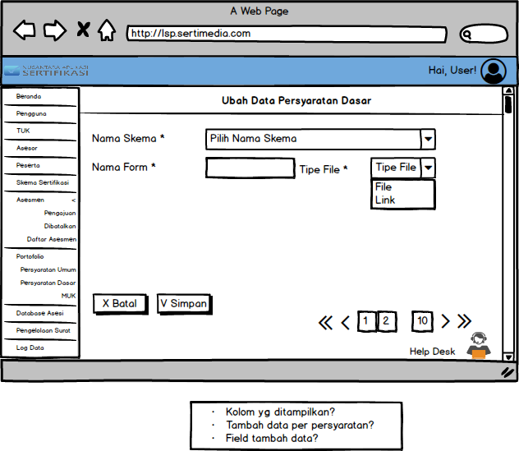

1. **Page MUK**

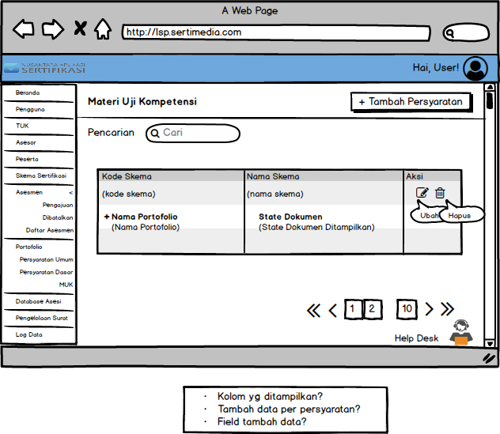

**Add MUK**

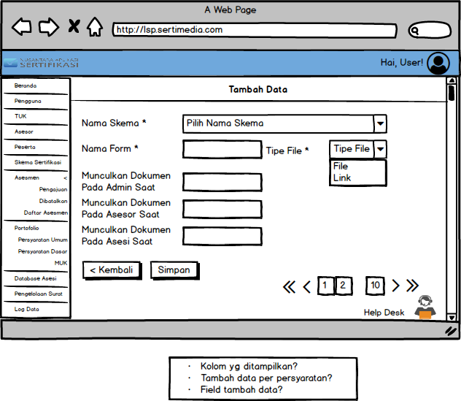

**Edit MUK**

(All fields on the edit page, will be filled in the existing data first)

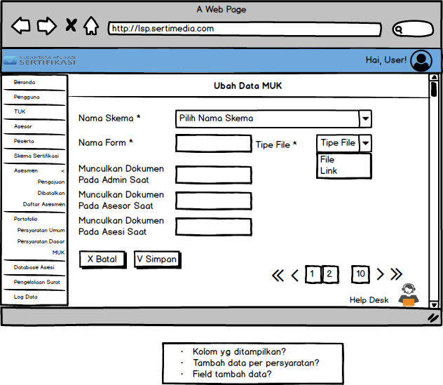

1. **The**  **asesi** Database page
2. **Main page of asesi**  **Database**

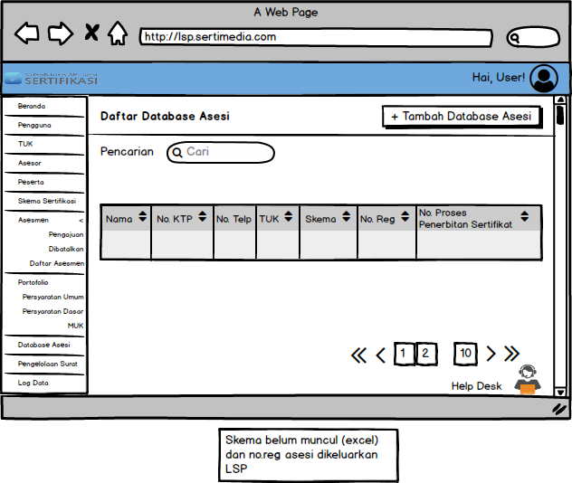

1. **Add Database**  **asesi**

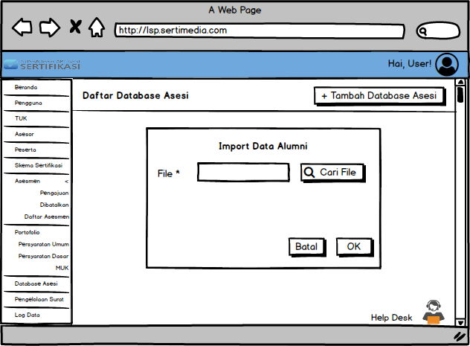

1. **Mail Management**  page

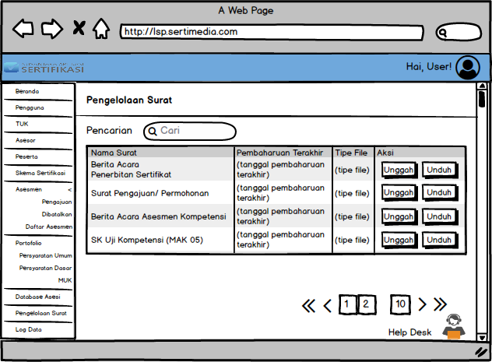

1. **Log Data** page

Data Log Assessment

